Classrooms Android Application v1.0

User’s Manual



Louiz Vincent Echiverri

Michael Vincent Ymbong

BS CS 4

Table of Contents

I. Introduction 3

Classrooms Application Flow 3

A. How to log-in 3

B. How to register 5

C. Home page 6

D. Classroom page 7

E. Profile Page 8

F. Write a new Post 9

G. How to create a new Classroom 10

H. Exploded post page 11

I. Navigation Drawer 12

Table of Figures

Figure 1 Log In Page for large and normal screen 3

Figure 2 register page 4

Figure 3 Home Page 5

Figure 4 Classroom Page 6

Figure 5 Profile Page 7

Figure 6 Write Post page 8

Figure 7 Classroom Creation page 9

Figure 8 Exploded post 10

Figure 9 Navigation Drawer 11

# Introduction

What is Classrooms? Classrooms focuses on one thing, to make an interactive classroom where students can have their own mini classroom both online and offline. In this app everyone can be a student or a teacher. Any user can create their own classroom where other users can join in or join other peoples’ classroom.

# Classrooms Application Flow

## How to log-in

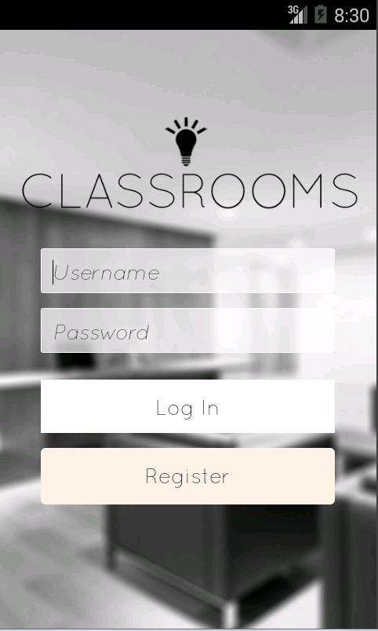

Figure 1 Log In Page for large and normal screen

When you open the application you will first see the log in page. In order for the user to login he has to provide his username and password. When he is finished inputting the data he can now press the Log In button to proceed to the home page. If the user does not have an account then they would have to press the Register button to proceed to the register page.

## How to register

## C:\Users\Michael\Pictures\android\New folder\register.png

Figure 2 register page

When the user presses the register button in the login page they are redirected to the register page where they are asked to fill in the username and password that are to be used in the app, as well as a valid email address and their profile picture. Pressing the select profile pic button redirects the user to their phone gallery to select a picture. The user is to press the Register button to send the data and proceed to their profile page.

## Home page

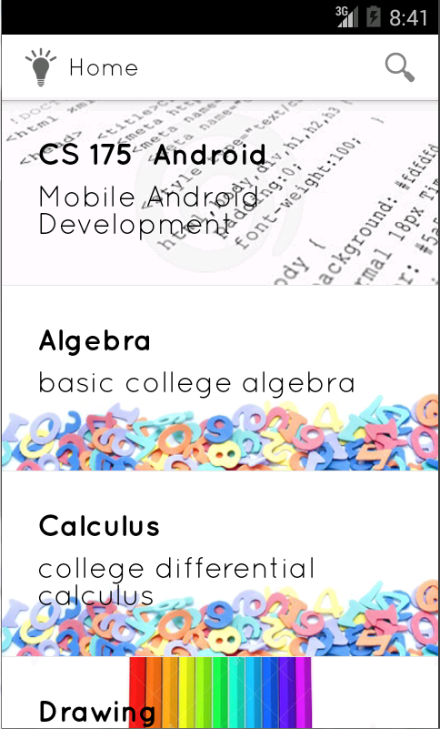

Figure 3 Home Page

After logging in, the user is brought to the home page, which shows the classrooms that are available in the app. The classrooms are shown as a list with a short description attached. To enter a classroom users just have to select an item from the list, which would redirect them to that classrooms page.

## Classroom page

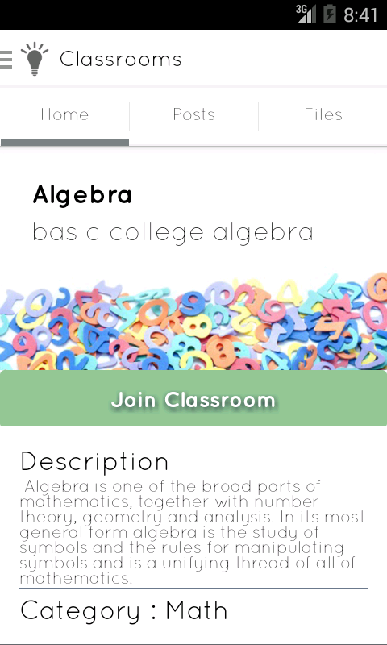 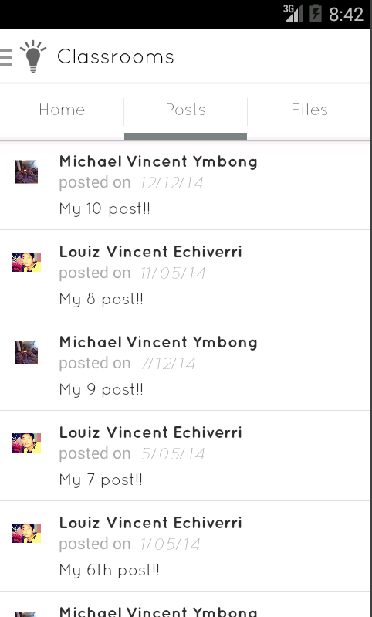 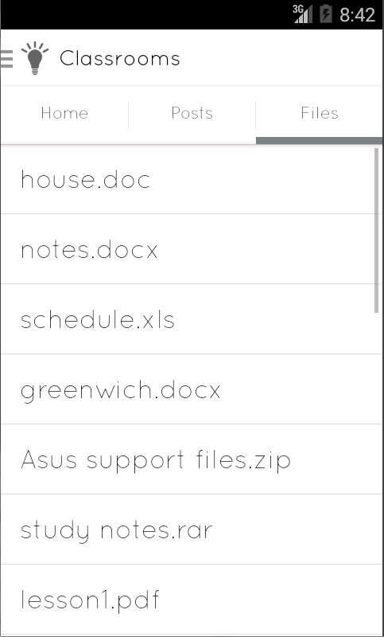

Figure 4 Classroom Page

The classroom page has 3 tabs namely home, posts, and files. The home tab show the basic information about the classroom. If you are not part of that classroom then a Join Classroom button is displayed that allows you to join the classroom. The posts tab displays posts from the users that are part of the classroom, selecting a post would redirect the user to an exploded post page. While the files tab shows files that users have uploaded to the classroom. Selecting a file would start a download to the user’s device.

## Profile Page

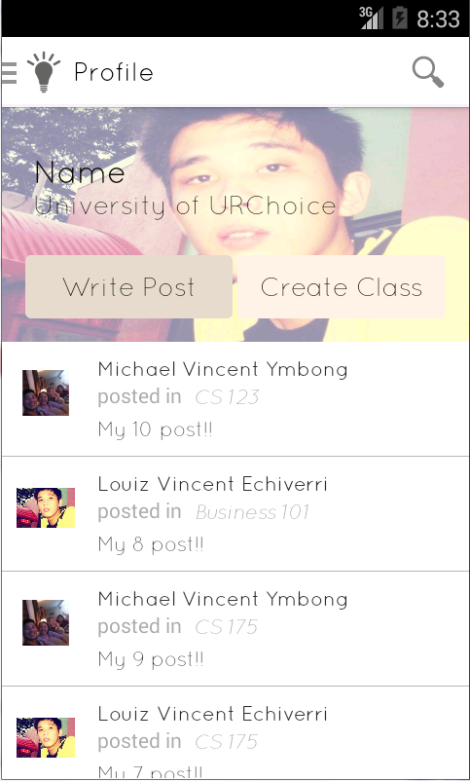

Figure 5 Profile Page

The profile page displays posts that were made in the classrooms that the user is part of, selecting a post redirects the user to an exploded view of the post. The user is redirected to the profile page after he has registered. There is also a link in the navigation drawer to the profile page. In the profile page the user can write a new post or create a new classroom. These actions are represented by their own buttons. Selecting either button redirects the user to a new page.

## Write a new Post

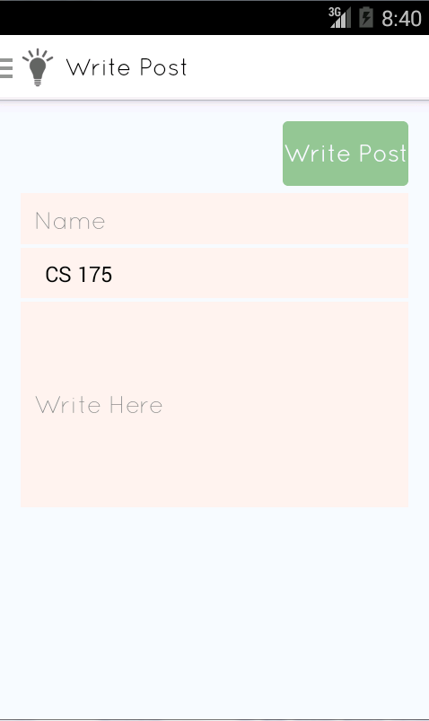

Figure 6 Write Post page

To write a new post the user must go to the Write Post page which can be accessed from the profile page and from a link on the navigation drawer sidebar. There are three required fields: the post name, the classroom to be posted in, and the post message. The location is selected from a list of classrooms that the user is part of in the form of a dropdown spinner. Pressing the write post button would redirect the user to the post location.

## How to create a new Classroom

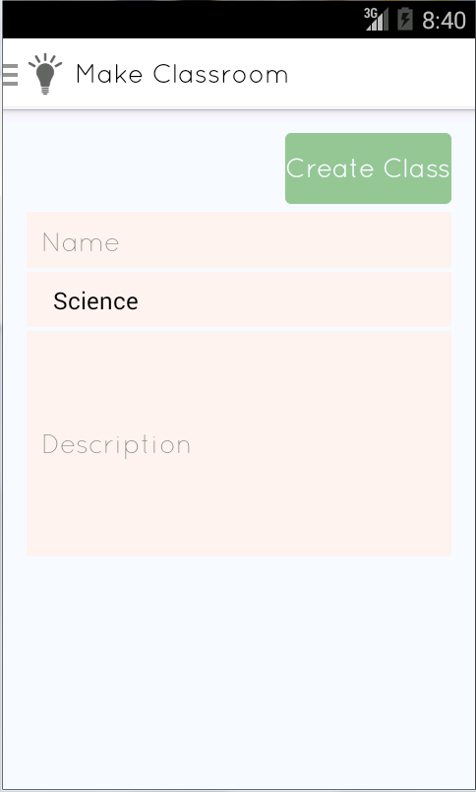

Figure 7 Classroom Creation page

To create a new classroom the user must go to the Classroom Creation page which can be accessed from the profile page and from a link on the navigation drawer sidebar. There are three required fields: the Classroom name, the classroom category, and the classroom description. The category is selected from a list provided for by the app in the form of a dropdown spinner. Pressing the create button would redirect the user to the new classroom.

## Exploded post page

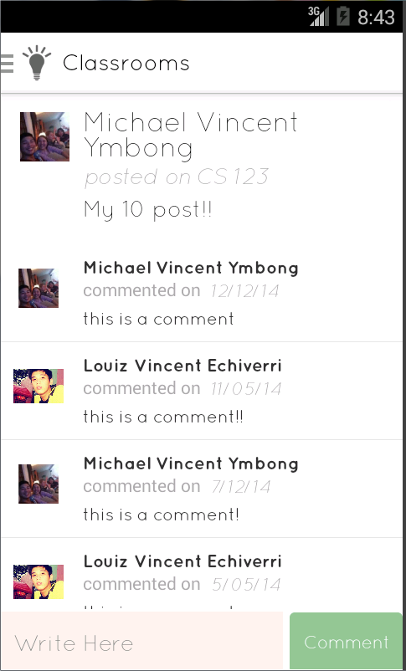

Figure 8 Exploded post

The exploded post page is displayed when the user selects a post from either the profile page or the classroom page. The user can see the comments on post as well as make their own comment. The user can comment through the comment box and select the comment button to post said comment.

## Navigation Drawer

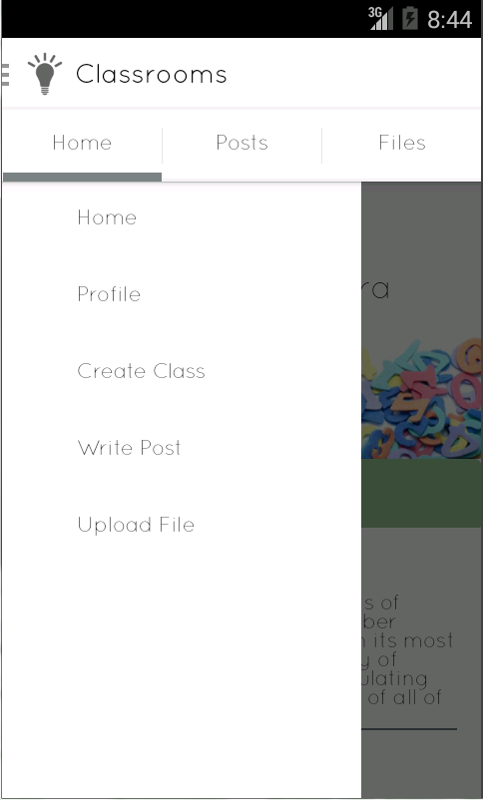

Figure 9 Navbar

The navbar is present all throughout the app. It is only hidden in the login and register pages. On the action bar the app logo as well as the page name is displayed. A sidebar menu has links to the home page, profile page, classroom creation page, write post page, as well as an option to upload a file.